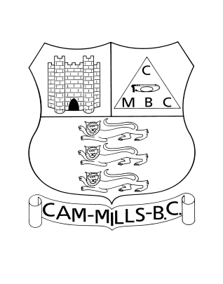
CAM MILLS BOWLING CLUB
Everlands, Cam, Dursley, Glos. GL11 5NL - Telephone: 01453 546823
APPLICATION FOR MEMBERSHIP

FULL NAME

AGE

ADDRESS | POSTCODE:
TELEPHONE NO.

E-MAIL ADDRESS

SIGNATURE

DATE

TYPE OF MEMBERSHIP APPLIED FOR: (TICK BOX)

SOCIAL + POSSIBLE BOWLER |  | FULL BOWLS MEMBER
SOCIAL MEMBER (including skittles) |  | JUNIOR MEMBER

The Application must be proposed and seconded by TWO EXISTING members of the Club.

PROPOSED BY |  | SECONDED BY
NAME |  | NAME
SIGNATURE |  | SIGNATURE
DATE |  | DATE

Reasons for wishing to become a member of the Club…………………………………………………………….

……………………………………………………………………………………………..……………………….

……………………………………………………………………………………………………..……………….

PLEASE CONFIRM THAT YOU AGREE WITH YOUR EMAIL ADDRESS & TELEPHONE NUMBER BEING AVAILABLE TO CLUB MEMBERS, ALSO PHOTOS MAY BE SHARED ON OUR CLUB FACEBOOK PAGES: YES / NO (Please circle your response)

Date of Meeting |  | Membership: Approved or Declined | Signed

PLEASE HAND YOUR COMPLETED FORM TO BAR STAFF AND YOUR APPLICATION WILL BE CONSIDERED
New Members General Data Protection Regulations Consent Form

The General Data Protection Regulations (GDPR) are in effect from 25 March 2018. These regulations require that the Club specifically obtains your consent for the collection and use of your personal information (data) and for its use in various ways, including communicating with you.

The Club has adopted a GDPR Policy, a copy of which is attached to this document. You are asked to read this Policy which covers the data held, how it is used and shared with others.

The Club uses this data solely for the purposes of the effective running of the Club and it does not share the data with anyone except the Gloucestershire Bowls Association (GBA) and Bowls England (BE) for some specific post holders within the Club as noted in the Policy. Within the Club, members data is shared only with team captains for team and match considerations. The data is not used in any form of automated decision making or profiling.

Any communications with you will be restricted to matters such as: GBA and BE issues; club meetings, minutes and events; availability for and selection of teams; and other such club related material. In addition, you are being asked to consent to the publication of your name and phone number(s) in the Club Handbook.

You have a number of rights concerning this data, namely:

- To request a copy of the data held about yourself from the Secretary, to be provided within one month;
- The correction of any inaccurate data, to be done within one month;
- The erasure of the data should you leave (or fail to re-join) the Club;
- To withdraw your consent to the use of the data for contact purposes; and,
- To report any suspected breach of data security to the Club Chairman.

You have the right to not consent to the club contacting you in any of the ways given below. Should you do so, however, you need to be aware that the club will not contact you about events, matches or urgent issues such as late cancellation of games.

In the case of young people, the information will not be published in the handbook.

The Club website will hold no openly available personal information.

We are asking you to confirm that you have read the GDPR Policy and that you consent to the Club using your data as described above and in the Policy. Please complete the table below

Name |  | Date
Please mark the appropriate box for each statement |  | Yes | No
I have read and accept the GDPR Policy
I consent to the Club contacting me by phone
I consent to the Club contacting me by e-mail
I consent to the Club contacting me by post
The Club Handbook may publish my Name
The Club Handbook may publish my Phone Number

